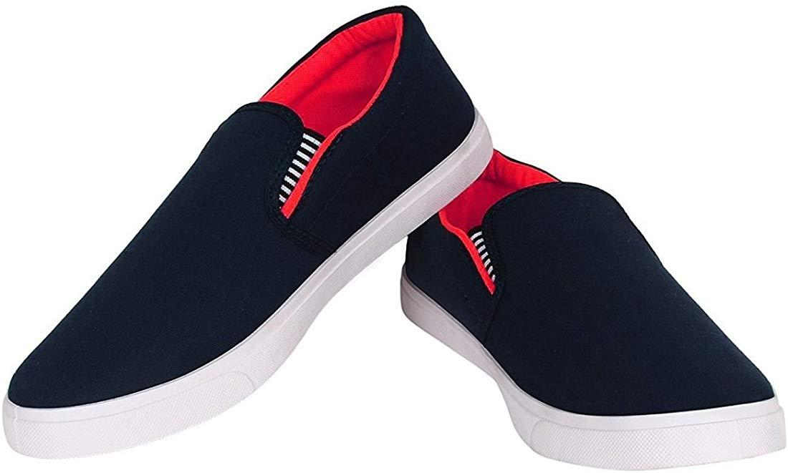

Shoes For Men's Shoes Casual Shoes Sneakers

Product details of Shoes For Men's Shoes Casual Shoes Sneakers

* Jeans Shoes
* Unisex
* Good Quality
* Rubber Sole
* Size 6-11
* Very Good and Comfortable
* NOTE:As Different Computers Display Colors Differently,The Color Of the Actual Item May Vary Slightly From The Above Images.NOTE:The Size Mark On The shoes Is Chinese Size Number.Warm Reminder:Different Shoe Styles,Please Select The Size According To Your Foot TypeIntroduction:1.High quality material,comfortable and soft,Reduces stress on joints,strengthens and tones,improves posture
* 2.casual shoes,Beach shoes, party shoes ,Non-slip, lightweight, , breathableEasy to wear Take off!
* 3.Tip design stylish, sight, personality,We have more sizes Colour design for You and yours family or lover Or friends select
* 4.Lightweight walking shoe,Convenient slip-on design,fashion and personality
* 5.Suitable for outdoor walking,Entertainment,leisure,party,work,Wedding and other occasions,color sturdy and stylish.

Specifications of Shoes For Men's Shoes Casual Shoes Sneakers

* Brand

No Brand

* SKU

155100455_PK-1320518738

* Apparel

Not Specified

* Age Range

Free Size